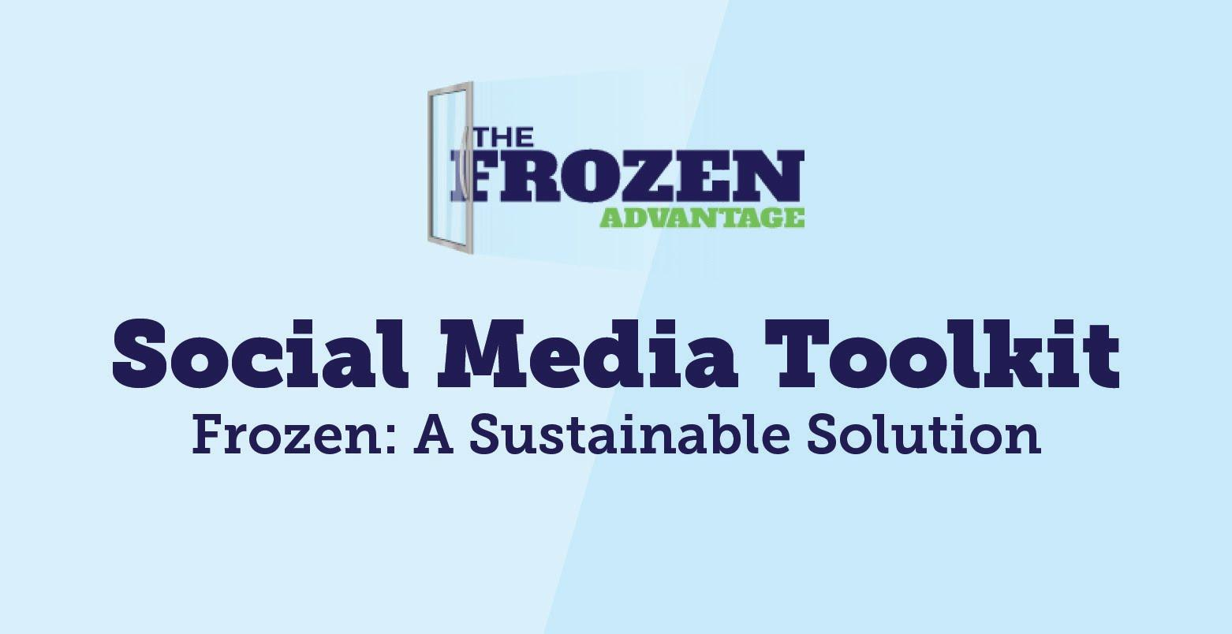

Introduction:
AFFI invites its members, partners and the public to help share how frozen food helps reduce waste and to share your company’s commitment to reduce frozen’s environmental footprint. This toolkit includes social media messaging and imagery for Facebook, Twitter and LinkedIn. Join in on the conversation by using these hashtags to support additional visibility with your social media messaging:
#FrozenAdvantage #FrozenFightsFoodWaste #FrozenFoods #FoodWasteSolution #FrozenFoodFacts #FrozenSustainability #SustainableSolutions

Instructions:
To use weekly content for each social channel, copy and paste messaging below into your Facebook, Twitter or LinkedIn feed.

Accompany each message with our pre-designed social image.

Post your status update and encourage others to join in on the conversation.

Best times to post for organic reach:
Facebook: Wednesday or Thursday between 11 am - 12 pm
Twitter: Wednesday or Friday between 8 am - 10 am
LinkedIn: Wednesday or Thursday between 8 am - 10 am

SUSTAINABILITY - FACEBOOK & LINKEDIN

- Food waste is a $162 billion dollar-a-year problem that frozen foods can help fix! When you buy frozen foods, you can eat what you want and store the rest for later while enjoying the convenience of meals or ingredients being ready when you are.
Learn more >> https://bit.ly/370VXNe

- Approximately 40% of the food we bring home is uneaten and ends up in landfills. Buying frozen food is the smart choice to help fight food waste!
Be a part of the solution >> https://bit.ly/370VXNe

- Why we ❤️ frozen foods 👇
- Reduces food waste by 47%
- 70% of secondary packaging is completely recyclable
- Lower in cost-per-serving with a greater shelf life
- Available in every season and in every community
Learn more about the frozen advantage >> https://bit.ly/370VXNe

- A recent study shows that 70% of secondary, outer packaging used for frozen foods is completely recyclable ♻️ Those recycled materials reduce solid waste and help contribute to a circular model for frozen food packaging, that in turn reduces C02 emissions.
Learn more about frozen food sustainability >> https://bit.ly/370VXNe

- Did you know? 💡
Forty percent of all food in the United States goes uneaten, an amount equivalent to $165 billion annually. Help fight food waste when you buy frozen foods! Watch to learn how frozen foods are the ideal food waste solution. https://bit.ly/3vxxedT

- Help save the planet by reducing food waste 🌎
Did you know we throw out 25% of the food we bring home? Buying frozen food generates 47% less waste when compared to fresh and refrigerated foods. Here's why frozen food is the solution to the food waste problem ⬇️
✅ Keep meals, fruits & veggies on hand year round
✅ Easily prepare what you need & store the rest for later
✅ Tasty meals are ready when you are
✅ 70% of secondary, outer frozen food packaging is completely recyclable
Learn more about frozen food sustainability >> https://bit.ly/370VXNe

- FACT: 89% of Americans think food waste is a concern and many families cannot afford to let food spoil. Here are 3 easy things you can do to be a part of the food waste solution:
1. Buy frozen foods for a long-term window before food goes to waste
2. Freeze leftovers and eat them when it’s convenient for you
3. Freeze meals and ingredients in advance to enjoy later
Learn more about fighting food waste >> https://bit.ly/370VXNe

- Freezing is nature's pause button ⏸️
Freezing simply pauses just-picked, just-baked and just-crafted foods - keeping them at their peak of freshness and locking in their flavor and nutrients.
Learn more about the path to frozen >> https://bit.ly/3d3VDB6

- FACT: 89% of Americans think food waste is a concern & many families cannot afford to let food spoil. Americans say they would attempt the following actions to reduce food waste: 76% would freeze leftovers, 72% would purchase frozen food and 69% would freeze meals & ingredients in advance.
Learn more >> https://bit.ly/370VXNe

SUSTAINABILITY - TWITTER

- Food waste is a $162 billion dollar-a-year problem that frozen foods can help fix! When you buy frozen foods, you can keep meals on-hand year-round and enjoy the convenience of meals being ready when you are.
Learn more about frozen food solutions >> https://bit.ly/370VXNe

- Approximately 40% of the food we bring home is uneaten and ends up in landfills. Buying frozen food is the smart choice to help fight food waste!
Be a part of the solution >> https://bit.ly/370VXNe

- Why we ❤️ frozen foods 👇
1. Reduces food waste by 47%
2. 70% of secondary packaging is completely recyclable
3. Lower in cost-per-serving with a greater shelf life
4. Available in every season and in every community
Learn more about the frozen advantage >> https://bit.ly/370VXNe

- A recent study shows that 70% of secondary, outer packaging used for frozen foods is completely recyclable ♻️ Those recycled materials reduce solid waste and help contribute to a circular model for frozen food packaging.
Learn more >> https://bit.ly/370VXNe

- Did you know? 💡
Forty percent of all food in the United States goes uneaten, an amount equivalent to $165 billion annually. Help fight food waste when you buy frozen foods! Watch to learn how frozen foods are the ideal food waste solution. https://bit.ly/3vxxedT

- Americans throw out 25% of the food we bring home. Buying frozen food generates 47% less waste when compared to fresh and refrigerated foods. Learn why frozen food is the solution to the food waste problem >> https://bit.ly/370VXNe

- FACT: 89% of Americans think food waste is a concern & many families cannot afford to let food spoil. Here’s what you can do to be a part of the food waste solution:
1. Buy frozen foods
2. Freeze leftovers
3. Freeze meals & ingredients in advance
Learn more >> https://bit.ly/370VXNe

- Freezing is nature's pause button ⏸️
Freezing simply pauses just-picked, just-baked and just-crafted foods - keeping them at their peak of freshness and locking in their flavor and nutrients.
Learn more about the path to frozen >> https://bit.ly/3d3VDB6

- FACT: 89% of Americans think food waste is a concern. Americans say they would attempt the following actions to reduce food waste: 76% would freeze leftovers, 72% would purchase frozen food and 69% would freeze meals & ingredients in advance.
Learn more > https://bit.ly/370VXNe

TEMPLATES - ALL CHANNELS

The frozen food industry is committed to reducing its environmental footprint! Here’s how [INSERT COMPANY NAME] is doing their part [INSERT YOUR COMPANIES ENVIRONMENTAL COMMITMENTS].

Frozen food growers, processors, manufacturers and retailers are working hard to reduce carbon dioxide emissions, water and energy use and solid waste within the frozen food supply chain. Here’s what we’re doing to reduce our environmental impact ⬇️ [INSERT ACTIONS IN GRAPHIC]

The frozen food industry is working hard to do their part to reduce their carbon footprint 👣 Here’s what we’re doing to help ⬇️ [INSERT ACTIONS IN GRAPHIC]

