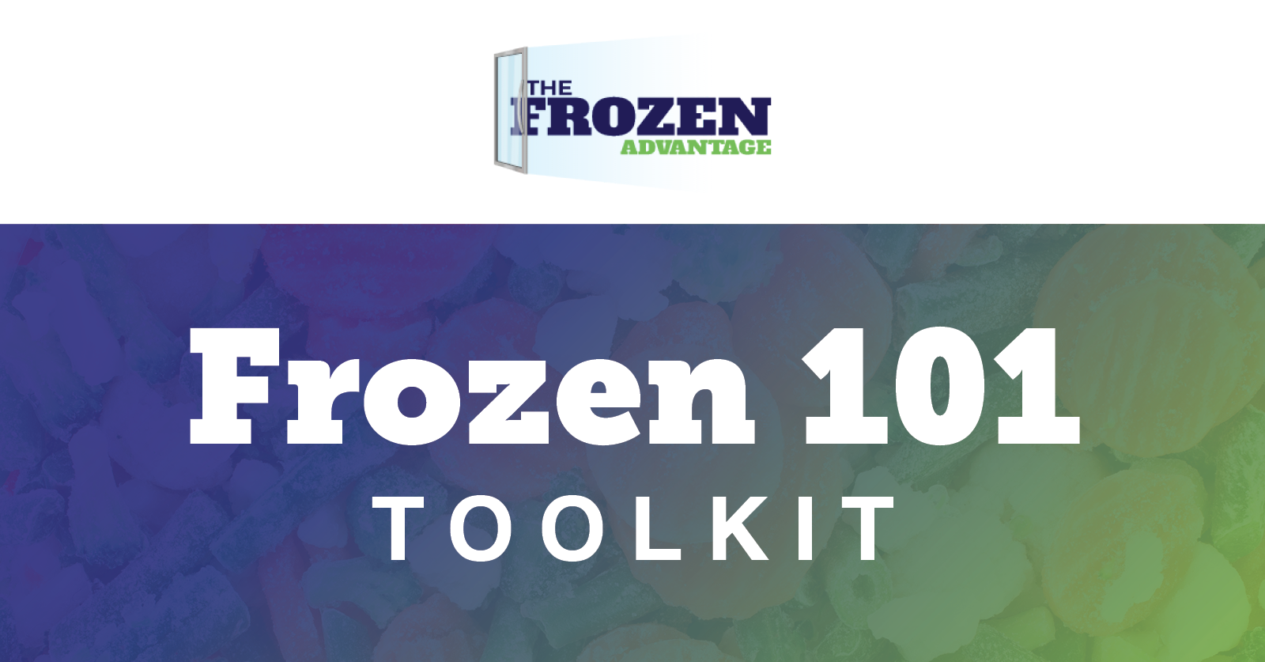

Introduction:
AFFI invites its members, partners and the public to help share the facts on frozen foods with our Frozen 101 Toolkit. This toolkit includes social media messaging and imagery for Facebook, Twitter and LinkedIn. Join us in debunking myths and answering consumers’ most frequently asked questions by using the hashtag #Frozen101

INSTRUCTIONS:
To use weekly content for each social channel, copy and paste messaging below into your Facebook, Twitter or LinkedIn feed.

Accompany each message with our pre-designed social image.

Post your status update and encourage others to join in on the conversation.

Suggested use:
Share the facts about frozen food weekly using our Frozen 101 Toolkit

Suggested hashtags:
Use hashtags to support additional visibility with your social messaging.
#FrozenAdvantage #FrozenFoods #FrozenFoodFacts #Frozen101

Best times to post for organic reach:
Facebook: Wednesday or Thursday between 11 am - 12 pm
Twitter: Wednesday or Friday between 8 am - 10 am
LinkedIn: Wednesday or Thursday between 8 am - 10 am

FROZEN 101 - FACEBOOK & LINKEDIN

- Don't overlook the frozen food aisle! ﻿Today’s shoppers can find plenty of nutritionally balanced — and portion controlled — meals in the frozen food section that help reduce waste while stretching your food dollar.
Get the Frozen 101 >> ﻿https://frozenadvantage.org/frozen-101/﻿

- Frozen or fresh? Fruits and vegetables are frozen almost immediately after harvest, locking in key nutrients and preventing spoilage during storage and transportation. According to research from the University of California-Davis and the University of Georgia, the nutritional value of frozen fruits and vegetables is equal to — and in some cases better than — fresh-stored produce.
Learn more >> https://frozenadvantage.org/frozen-101/

- Freezing is the most ancient form of preservation and modern-day freezing technology allows you to enjoy every type of frozen food. When food is frozen, water is converted to ice which reduces the reactions that spoil food.
Learn more >> https://frozenadvantage.org/about/path-to-frozen/

- Freezing means less waste 📉
Approximately 40% of food in the home is uneaten and ends up in landfills. Thankfully, more than 70% of Americans are using frozen foods to cut down on food waste. Frozen foods minimize the amount of spoiled food we throw away because frozen fruits, vegetables and prepared meals can be used when needed, portioned accordingly and/or stored for later use.
Learn more >> https://frozenadvantage.org/less-waste/

- Frozen food helps American families spend less than 5% of their income on food at home. It is delicious, nutritious and helps families meet their food and nutrition goals while ensuring they spend less over time.
Learn more >> https://frozenadvantage.org/economical/

- Today’s shoppers can find plenty of nutritionally balanced — and portion controlled — meals in the frozen food aisle. Frozen and fresh ingredients can be combined in the same meal, such as including some quick-steam frozen vegetables alongside a freshly prepared entrée. In fact, a recent study showed 72% of consumers mix and match frozen foods with fresh ingredients.
Learn more >> https://frozenadvantage.org/frozen-101/

- Today’s frozen food aisle offers new, innovative entrée and side dish options that meet consumers’ evolving needs and demands for more whole grains, high protein and plant-based protein, low sodium, low fat, portion-controlled and other healthier options.
See the options >> https://frozenadvantage.org/variety/

- It’s important to follow preparation and cooking instructions on frozen foods for the best quality and safety. For example, while frozen fruits are ready-to-eat and don’t bear cooking instructions, frozen vegetables need to be cooked according to package cooking instructions.
Learn more >> https://bit.ly/3jqjuO3

- ﻿You asked and we answered!
Q: How long can frozen food be kept in the freezer?
﻿A: ﻿﻿According to FoodSafety.gov, frozen foods stored continuously at 0 °F or below can be kept indefinitely. However, this does not account for quality. For quality, refer to this cold food storage chart for the recommended amount of time to store your frozen food.
﻿Get answers to more frequently asked questions here >> ﻿https://frozenadvantage.org/frozen-101/﻿

FROZEN 101 - TWITTER

- Don't overlook the frozen food aisle! ﻿Today’s shoppers can find plenty of nutritionally balanced — and portion controlled — meals in the frozen food section that help reduce waste while stretching your food dollar.
Get the Frozen 101 >> https://bit.ly/3atT5Kg

- Frozen or fresh? Fruits and vegetables are frozen almost immediately after harvest, locking in key nutrients and preventing spoilage during storage and transportation.
Learn more >> https://bit.ly/3atT5Kg

- Freezing is the most ancient form of preservation and modern-day freezing technology allows you to enjoy every type of frozen food. When food is frozen, water is converted to ice which reduces the reactions that spoil food.
Learn more >> https://bit.ly/2YSFHfW

- Freezing means less waste 📉
Approximately 40% of food in the home is uneaten and ends up in landfills. Thankfully, more than 70% of Americans are using frozen foods to cut down on food waste. Frozen foods minimize the amount of spoiled food we throw away because frozen fruits, vegetables and prepared meals can be used when needed, portioned accordingly and/or stored for later use.
Learn more >> https://bit.ly/3lIT4Za

- About 40% of food in the home ends up in landfills. Thankfully, 70% of Americans are using frozen foods to cut down on food waste. Frozen foods reduce the amount of food we throw away because frozen fruits, veggies & prepared meals can be used when needed https://bit.ly/3lIT4Za

- Today’s shoppers can find plenty of nutritionally balanced meals in the frozen food aisle. Frozen & fresh ingredients can be combined in the same meal, such as including some quick-steam frozen vegetables alongside a freshly prepared entrée.
Learn more >> https://bit.ly/3atT5Kg

- Today’s frozen food aisle offers new, innovative options that meet consumers’ evolving needs and demands for more whole grains, high protein and plant-based protein, low sodium, low fat, portion-controlled and other healthier options.
See the options >> https://bit.ly/3aDVbHz

- It’s important to follow preparation and cooking instructions on frozen foods for the best quality and safety. While frozen fruits are ready-to-eat and don’t bear cooking instructions, frozen veggies need to be cooked according to package instructions.
https://bit.ly/3jqjuO3

- How long can frozen food be kept in the freezer?
According to FoodSafety.gov, frozen foods stored continuously at 0 °F or below can be kept indefinitely. However, this does not account for quality. For quality, refer to this cold food storage chart.
https://bit.ly/3atT5Kg﻿

MYTHS VS. FACTS - FACEBOOK & LINKEDIN

- MYTH ❌ Frozen fruits and veggies aren’t as nutritious as fresh.
FACT ✅ Recent studies found that there is no difference in nutrition between frozen produce and fresh produce and, in some cases, frozen can be higher in nutrients than fresh-stored produce.
Find out the real deal here >> https://frozenadvantage.org/frozen-food-facts/﻿

- MYTH ❌ Frozen meals don't use real ingredients.
FACT ✅ The freezer aisle of your supermarket is filled with meals made with the highest quality ingredients and prepared the way you would (if you had the time).﻿
Find out the real deal here >> https://frozenadvantage.org/frozen-food-facts/﻿

- MYTH ❌ Frozen foods are ready to eat.
FACT ✅ Frozen foods include on-package cooking instructions for quality and safety. Be sure to follow the cooking directions to keep you and your family safe and to ensure the best tasting food.
Find out the real deal here >> https://frozenadvantage.org/frozen-food-facts/﻿

- MYTH ❌ Frozen meals aren’t environmentally friendly.
FACT ✅ Actually, frozen foods minimize the amount of spoiled food we throw away because they’re already portioned out for us, so we can take what we need and save the rest for later use.
Find out the real deal here >> https://frozenadvantage.org/frozen-food-facts/﻿

- MYTH ❌ All frozen foods contain added preservatives.
FACT ✅ Freezing is a natural form of preservation, so added preservatives aren’t necessary to preserve frozen food.
Find out the real deal here >> https://frozenadvantage.org/frozen-food-facts/﻿

- MYTH ❌ Frozen meals aren’t a good choice for health-conscious consumers.
FACT ✅ “Better-for-you” options are available in the frozen food aisle to make it easier for consumers to control intakes of calories, fat, saturated fat and sodium.
Find out the real deal here >> https://frozenadvantage.org/frozen-food-facts/﻿

MYTHS VS. FACTS - TWITTER

- MYTH ❌ Frozen fruits & veggies aren’t as nutritious as fresh
FACT ✅ Recent studies found that there is no difference in nutrition between frozen & fresh produce. In some cases, frozen can be higher in nutrients than fresh-stored produce.
Learn more >> https://bit.ly/3tY8REU

- MYTH ❌ Frozen meals don't use real ingredients
FACT ✅ The freezer aisle of your supermarket is filled with meals made with the highest quality ingredients and prepared the way you would (if you had the time).﻿
Learn more >> https://bit.ly/3tY8REU

- MYTH ❌ Frozen foods are ready to eat
FACT ✅ Frozen foods include on-package cooking instructions for quality and safety. Be sure to follow the cooking directions to keep you and your family safe and to ensure the best tasting food.
Learn more >> https://bit.ly/3tY8REU

- MYTH ❌ Frozen meals aren’t environmentally friendly
FACT ✅ Frozen foods minimize the amount of spoiled food we throw away because they’re already portioned out for us, so we can take what we need and save the rest for later use.
Learn more >> https://bit.ly/3tY8REU

- MYTH ❌ All frozen foods contain added preservatives.
FACT ✅ Freezing is a natural form of preservation, so added preservatives aren’t necessary to preserve frozen food.
Find out the real deal here >> https://bit.ly/3tY8REU

- MYTH ❌ Frozen meals aren’t a good choice for health-conscious consumers
FACT ✅ “Better-for-you” options are available in the frozen food aisle to make it easier for consumers to control intakes of calories, fat, saturated fat & sodium
Learn more >> https://bit.ly/3tY8REU

