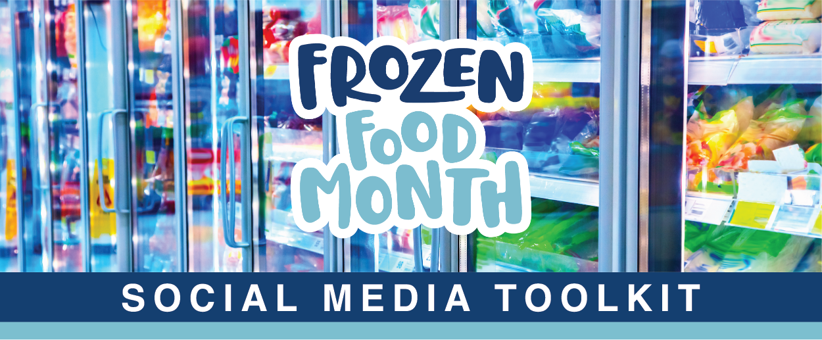

Introduction:
Social media provides a powerful opportunity to bring awareness to National Frozen Food Month. This toolkit will assist in high quality social media messaging and imagery for Facebook, Twitter and LinkedIn. Join in our efforts to effectively bring awareness and educate users on the benefits of frozen foods and be sure to use our hashtag #FrozenAdvantage.

Instructions:
To use weekly content for each social channel, copy and paste messaging below into your Facebook, Twitter or LinkedIn feed.

Accompany each message with our pre-designed social image.

Post your status update and encourage others to join in the conversation during National Frozen Food Month.

Suggested use:
Post 1-2 messages per week on each social media channel as indicated below.

Suggested hashtags:
Use hashtags to support additional visibility with your social messaging.
#FrozenAdvantage #NationalFrozenFoodMonth #FrozenFoods2022 #FrozenFoodMonth #FrozenFoods #MarchIsFrozenFoodMonth

Best times to post for organic reach:
Facebook: Wednesday or Thursday between 11 am - 12 pm
Twitter: Wednesday or Friday between 8 am - 10 am
LinkedIn: Wednesday or Thursday between 8 am - 10 am

March 1st - 5th (2 postings)

Facebook & LinkedIn:
1. March is #NationalFrozenFoodMonth! Did you know that frozen fruits and vegetables have the same nutritional benefits as fresh produce, sometimes even more? Whether frozen, fresh, dried or canned, all forms of fruits and vegetables provide essential nutrients! Learn more at >> http://bit.ly/3d3V9v2
2. Frozen foods are always in season! The frozen food aisle offers a wide variety of quality products from ingredients to side dishes and entrées for a more affordable price. Learn more >> http://bit.ly/3aXveCw

Twitter:
1. March is #NationalFrozenFoodMonth! Did you know that frozen fruits and vegetables have the same nutritional benefits as fresh produce, sometimes even more? Learn more at >> http://bit.ly/3d3V9v2
2. Frozen foods are always in season! The frozen food aisle offers a wide variety of quality products from ingredients to side dishes and entrées for a more affordable price. Learn more >> http://bit.ly/3aXveCw

LinkedIn:
1. March is #NationalFrozenFoodMonth! Did you know that frozen fruits and vegetables have the same nutritional benefits as fresh produce, sometimes even more? Whether frozen, fresh, dried or canned, all forms of fruits and vegetables provide essential nutrients! Learn more at >> http://bit.ly/3d3V9v2
2. Frozen foods are always in season! The frozen food aisle offers a wide variety of quality products from ingredients to side dishes and entrées for a more affordable price. Learn more >> http://bit.ly/3aXveCw

March 6th - 12th (2 postings)

Facebook:
1. For #NationalFrozenFoodMonth we’re challenging you to fight food waste by buying frozen foods! Because frozen foods have a greater shelf life than fresh or refrigerated foods, they help reduce food waste by 47%. Learn more about the benefits of frozen foods >> http://bit.ly/370VXNe
2. Let’s talk fresh vs. frozen, what’s the difference? Frozen fruits and vegetables are picked at peak ripeness, are more affordable and last longer while providing the same nutrients as fresh produce! See the difference >> http://bit.ly/3tOwBvS

Twitter:
1. For #NationalFrozenFoodMonth we’re challenging you to fight food waste by buying frozen foods! Because frozen foods have a greater shelf life than fresh or refrigerated foods, they help reduce food waste by 47%. Learn more >> http://bit.ly/370VXNe
2. Let’s talk fresh vs. frozen! Frozen fruits and vegetables are picked at peak ripeness, are more affordable and last longer while providing the same nutrients as fresh produce! See the difference >> http://bit.ly/3tOwBvS

LinkedIn:
1. For #NationalFrozenFoodMonth we’re challenging you to fight food waste by buying frozen foods! Because frozen foods have a greater shelf life than fresh or refrigerated foods, they help reduce food waste by 47%. Learn more about the benefits of frozen foods >> http://bit.ly/370VXNe
2. Let’s talk fresh vs. frozen, what’s the difference? Frozen fruits and vegetables are picked at peak ripeness, are more affordable and last longer while providing the same nutrients as fresh produce! See the difference >> http://bit.ly/3tOwBvS

March 13th - 19th (2 postings)

Facebook:
1. Learn more about the journey from farm to freezer during #NationalFrozenFoodMonth. There is a story behind every frozen food from the ingredients that are picked and prepared at the peak of freshness to the people involved in every step of creation, frozen food makers take pride in feeding you. Find their story here >> http://bit.ly/3d3VDB6
2. Buy frozen & save! When you buy frozen food you can eat how much you want (thanks to resealable packaging) and when you want it (thanks to a longer shelf life) without worrying about it going to waste, making your dollar go further with a lower cost-per-serving. Learn more >> http://bit.ly/3aTGHCY

Twitter:
1. Learn more about the journey from farm to freezer and the frozen food makers that take pride in feeding you during #NationalFrozenFoodMonth. Find their story here >> http://bit.ly/3d3VDB6
2. Buy frozen & save! Thanks to frozen foods innovative packaging you can eat how much you want and when you want it without worrying about it going to waste. Learn more >> http://bit.ly/3aTGHCY

LinkedIn:
1. Learn more about the journey from farm to freezer during #NationalFrozenFoodMonth. There is a story behind every frozen food from the ingredients that are picked and prepared at the peak of freshness to the people involved in every step of creation, frozen food makers take pride in feeding you. Find their story here >> http://bit.ly/3d3VDB6
2. Buy frozen & save! When you buy frozen food you can eat how much you want (thanks to resealable packaging) and when you want it (thanks to a longer shelf life) without worrying about it going to waste, making your dollar go further with a lower cost-per-serving. Learn more >> http://bit.ly/3aTGHCY

March 20nd - 26th (2 postings)

Facebook:
1. Spend more quality time around the table during #NationalFrozenFoodMonth with total meal solutions and pre-cleaned and chopped ingredients. From macaroni & cheese and desserts to pizza and Asian fare, frozen foods make mealtime easier providing the right ingredients and clear cooking instructions! Find recipes your family will love >> http://bit.ly/3tRpliH
2. Frozen foods taste great because the food IS great! Eat smart by choosing a variety of frozen foods that are nutritious, affordable, easy to prepare and reduce food waste. Learn more >> http://bit.ly/3tOwBvS

Twitter:
1. Spend more quality time around the table during #NationalFrozenFoodMonth with total meal solutions and pre-cleaned and chopped ingredients! Find recipes your family will love here >> http://bit.ly/3tRpliH
2. Frozen foods taste great because the food IS great! Eat smart by choosing a variety of frozen foods that are nutritious, affordable, easy to prepare and reduce food waste. Learn more >> http://bit.ly/3tOwBvS

LinkedIn:
1. Spend more quality time around the table during #NationalFrozenFoodMonth with total meal solutions and pre-cleaned and chopped ingredients. From macaroni & cheese and desserts to pizza and Asian fare, frozen foods make mealtime easier providing the right ingredients and clear cooking instructions! Find recipes your family will love >> http://bit.ly/3tRpliH
2. Frozen foods taste great because the food IS great! Eat smart by choosing a variety of frozen foods that are nutritious, affordable, easy to prepare and reduce food waste. Learn more >> http://bit.ly/3tOwBvS

March 27th - 31st (1 postings)

Facebook:
1. With #NationalFrozenFoodMonth coming to an end, remember frozen foods offer certainty during uncertain times. Stock up on frozen foods now and you’ll have healthy and easy-to-prepare foods for later without having to run to the store multiple times a month! Learn more about the #FrozenAdvantage here >> http://bit.ly/3tOwBvS

Twitter:
1. With #NationalFrozenFoodMonth coming to an end, remember frozen foods offer certainty during uncertain times. Stock up on frozen foods now and enjoy the accessibility later saving you trips to the store! Learn more about the #FrozenAdvantage here >> http://bit.ly/3tOwBvS

LinkedIn:
- With #NationalFrozenFoodMonth coming to an end, remember frozen foods offer certainty during uncertain times. Stock up on frozen foods now and you’ll have healthy and easy-to-prepare foods for later without having to run to the store multiple times a month! Learn more about the #FrozenAdvantage here >> http://bit.ly/3tOwBvS

